<https://www.coursera.org/account/accomplishments/certificate/R3T2F9QQ9M6M>

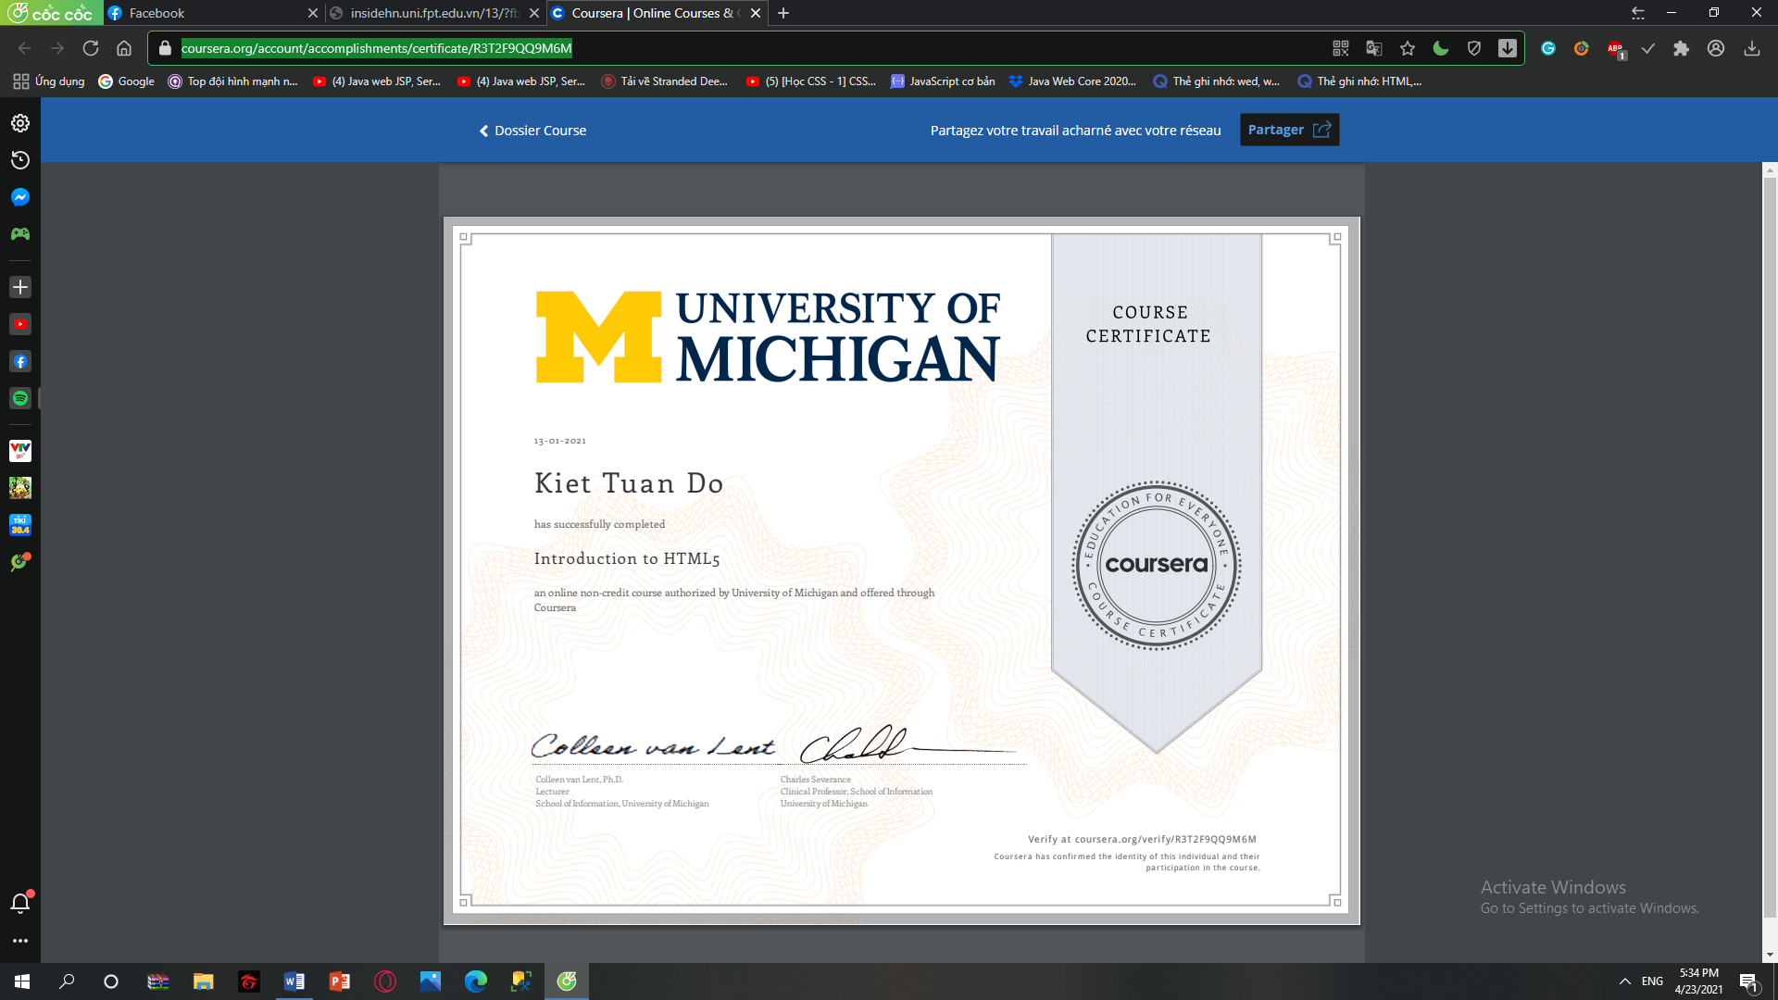

<https://www.coursera.org/account/accomplishments/certificate/WJYQM9666Z3H>



<https://www.coursera.org/account/accomplishments/certificate/6SBNUQN7B5XY>



<https://www.coursera.org/account/accomplishments/certificate/FRMQANGNYUAE>



<https://www.coursera.org/account/accomplishments/certificate/4YZRH2LPYQSZ>



<https://www.coursera.org/account/accomplishments/specialization/certificate/JJRRENHLZDXG>

